PROGRAM
import cv2
import numpy as np

img = cv2.imread("rotation_image.png")

if img is None:
print("Image not found! Check the image name.")
else:
rows, cols = img.shape[:2]

pts1 = np.float32([
[0, 0],
[cols - 1, 0],
[0, rows - 1],
[cols - 1, rows - 1]
])

pts2 = np.float32([
[100, 50],
[cols - 100, 0],
[50, rows - 50],
[cols - 50, rows - 100]
])

matrix = cv2.getPerspectiveTransform(pts1, pts2)

transformed = cv2.warpPerspective(
img, matrix, (cols, rows)
)

cv2.imshow("Original Image", img)
cv2.imshow("Perspective Transformed Image", transformed)

cv2.imwrite("perspective_transformed.png", transformed)

cv2.waitKey(0)
cv2.destroyAllWindows()

print("Perspective transformation completed successfully!")

OUTPUT
The original image and the perspective-transformed image are displayed. The transformed image shows a change in perspective due to the shifting of its four corner points. The output is saved as perspective_transformed.png.
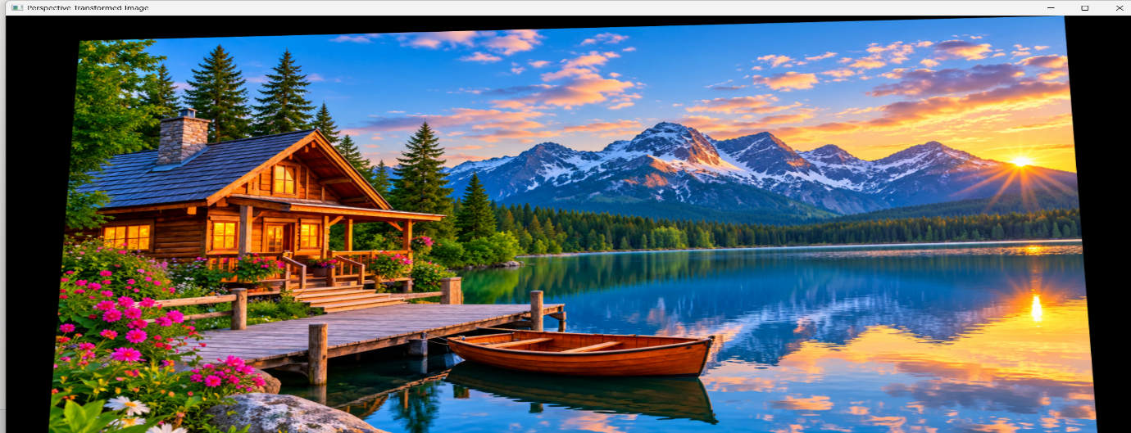
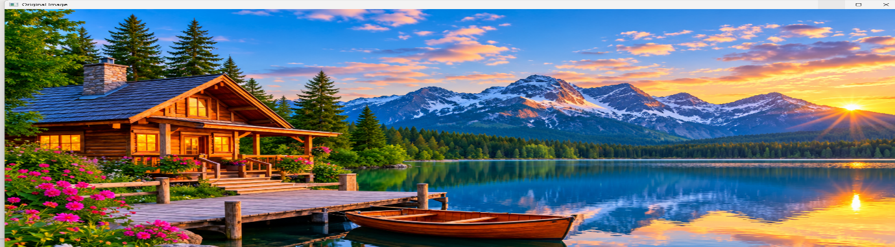

RESULT
Thus, perspective transformation was successfully performed on the given image using Python and OpenCV.

